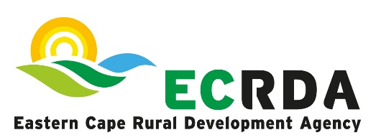

RE: CANCELLATION OF A BID
Reference Number: RFQ 09- 2023/24

Description: SUPPLY, DELIVERY AND INSTALLATION OF THE HYDROPONIC IRRIGATION SYSTEM UNDER A VEGETABLE TUNNEL AT TSHABO BLOCK 2 SITE NEAR NTABOZUKO (FORMERLY BERLIN), BCMM

Please note, the above-mentioned tender has been cancelled due to damaged tunnels where the irrigation system was supposed to be installed.

Enquiries may be directed to Mr A Xoxani -Telephone: 043 703 6300 or email: xoxania@ecrda.co.za.

