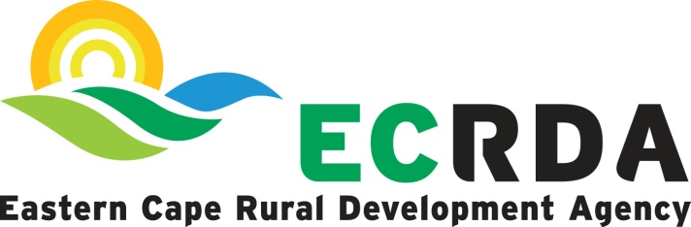
EXTERNAL ADVERTISEMENT

Overview of the Entity

The Eastern Cape Rural Development Agency (ECRDA) is a schedule 3C entity in terms of the Public Finance Management Act 1, of 1999 as amended, with a mandate to promote, support and facilitate rural development in the Province.

Position : Manager: Organisational Performance, Planning and Reporting
Grade : 17
Reporting Line : Office of the CEO

Location : East London (head office)

Duration : Permanent

Main purpose of the position:

Leading and coordinate the development of the organisational strategy and monitor its implementation.

Minimum Requirements:

Educational

- Honours degree in either Social/ Applied Sciences, Business Administration, Public Administration, Business Management, Development Studies, Organisational Development, Organisational psychology, and / or related filed.
- Master’s qualification will be an added advantage.

Driving
- Code 08 drivers license

Experience
- 10 years working experience.
- 5 -7 years’ experience in operational planning, monitoring, evaluation and reporting.

KNOWLEDGE COMPETENCY AND ATTRIBUTES

- Moral Competence
- Planning and Organising
- Analysis and Innovation
- Knowledge and Information Management
- Strategic Thinking
- Communication
- Results and Quality Focus

DUTIES

- Leadership
- Planning and Management
- Planning, organising and reporting
- Monitoring and evaluation
- Reporting
- Policy and legislation
- Management
- Strategic planning
- Stakeholder Engagement and Knowledge management

Remuneration

The position is offering a negotiable minimum salary of R1,057,148

GENERAL INFORMATION

The application, which should as minimum contain a covering letter, CV, Employment application form, Certified copy of your Identity document, qualifications and drivers’ licence must be submitted to recruitment@ecrda.co.za.

NB:
- Without prejudice, correspondence will be limited to the shortlisted candidates.
- Further be informed that if you have not been contacted within a week of the closing date, please accept that your application was unsuccessful.
- ECRDA reserves a right to appoint or not to make an appointment.
- Interviews will be conducted in person, unless stated otherwise.
- Administrative enquiries may be directed via email to mtumtumL2@ecrda.co.za
- Canvasing will lead to disqualification of an application.
- ECRDA has an employment equity plan which will be considered when making the appointment into this position.

- Date of issue : 25 September 2026
CLOSING DATE: 09 October 2026 before 16h30, Late applications will not be accepted.

